Do you or someone you know have Nephrotic Syndrome or related kidney disease such as Minimal Change Disease, FSGS, IgM Nephropathy, or Membranous Nephropathy?

Please consider participating in a 1-hour long interview with the Prepare-NS research study.
Researchers are studying people’s experiences with swelling, or edema, and want to learn from those impacted by Nephrotic Syndrome. The information collected from the interviews will be used to develop a survey to use when testing new medications for Nephrotic Syndrome.
What is involved?
- A one-hour long phone or Zoom interview discuss your experiences with swelling
- Receive $50 after the interview
Who can participate?
Group 1: Caregivers of children with nephrotic syndrome  - Parent/guardians must be at least 18 years old  - Must be able to read and understand English.  - Are caring for a child aged 2-11 years with a diagnosis of Nephrotic Syndrome or a specific kidney disease that causes Nephrotic Syndrome, such as Minimal Change Disease, FSGS, IgM Nephropathy, or Membranous Nephropathy.  - Their child must have current swelling or a history of swelling within the past 3 months.  - Their child must not be receiving dialysis. | Group 2: People with nephrotic syndrome  - At least 8 years old  - Are able to read and understand English.  - Have a diagnosis of Nephrotic Syndrome or a specific kidney disease that causes Nephrotic Syndrome, such as Minimal Change Disease, FSGS, IgM Nephropathy, or Membranous Nephropathy.  - Must have current swelling or a experienced swelling within the past 3 months.  - Must not be receiving dialysis.

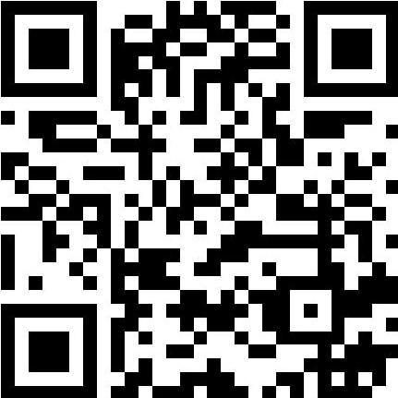
Your participation in the Prepare-NS interview study could help researchers get one step closer to finding new therapies for Nephrotic Syndrome!

If you are interested or would like more information, contact the Prepare-NS team by calling 734-232-4830 or emailing Prepare-NS-study@umich.edu.

The study is sponsored by the U.S. Food and Drug Administration and conducted by researchers from the University of Michigan and Northwestern University. It has been approved by The University of Michigan Institutional Review Board HUM00208148.

